

**CSE2007 : Database Management Systems**

**Name :** Gudi Varaprasad

**Reg. No. :** 19BCE7048

School of Computer Science and Engineering

**Lab Slot :** L45 + L46

**Date :** 22 – 04 – 2021

**Submitted to :** Ms. Dhanavanthini madam

**PL / SQL Programming**

**SQL > set serveroutput on**

**1. Write PL/SQL code for finding Even Numbers.**

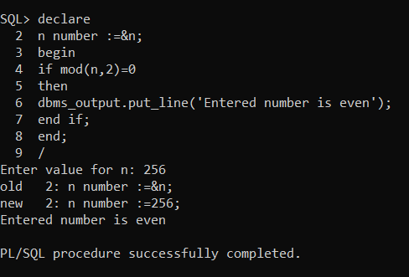

**2. Write PL/SQL code to find Largest of three numbers.**

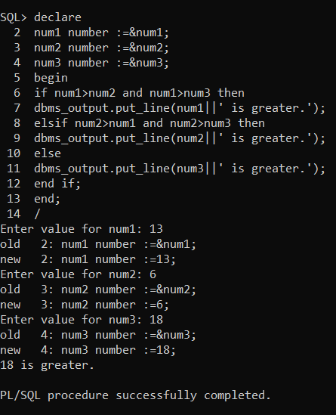

**3. Write PL/SQL code to find Factorial of a given number.**

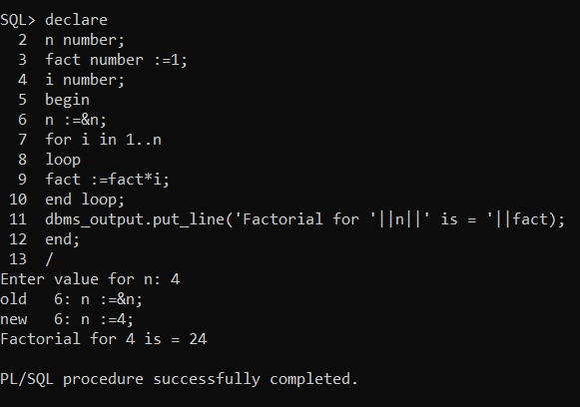

**4. Write PL/SQL code to Read number and prints its Multiplication Table.**

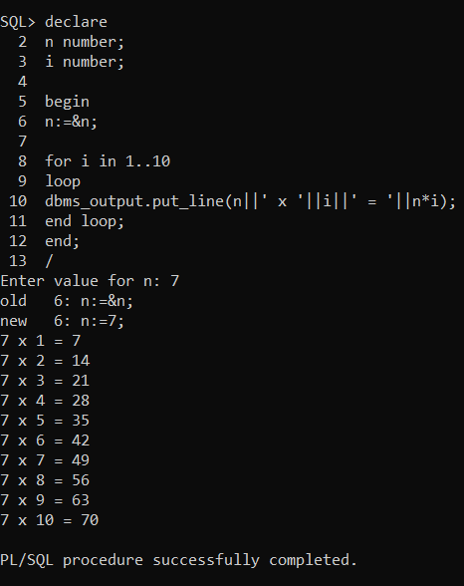

**5. Write PL/SQL code to find given number is Prime or not.**

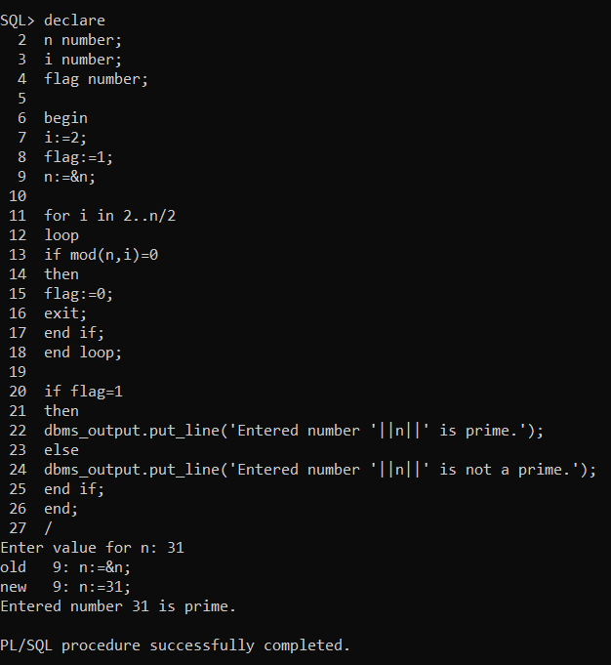

**6. Write PL/SQL code to accept the text and reverse the text and test whether the given character is Palindrome or not.**

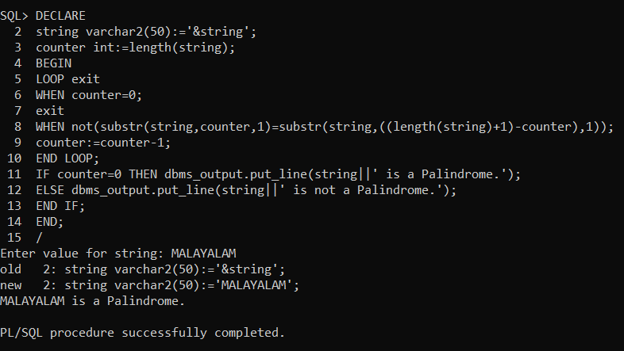

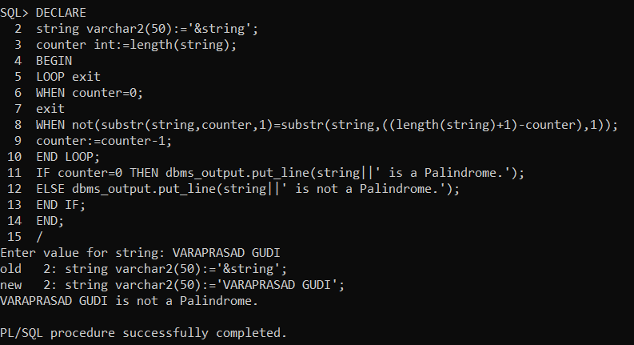

**7. Write PL/SQL code to find Reverse of a given number.**

